Jean-PierrePetit  
[Jppetit1937@yahoo.fr](mailto:Jppetit1937@yahoo.fr)  
BP 55 84122 Pertuis, France

Pertuis, on December 31, 2019

to Mr. T.Damour

IHES, route des Chartres

91440 Bures sur Yvette

France

Recommended with acknowledgement of receipt

Copies to :

Etienne Ghys, Permanent Secretary of the Academy of Sciences

Director of the Institut des Hautes Etudes Scientifiques

Sir,

More than three months have passed since my letter of 26 September 2019, which remained unanswered. A letter that included all the elements of a reply to the article that you posted on January 7, 2019 on your page of the IHES site, which concluded "to the physical and mathematical incoherence of the Janus model", based on the difficulty of describing the geometry inside the stars.

I brought all the elements that put this model back on its foundations at the price of a minimal modification of the tensors of the second member, which ensures the satisfaction of Bianchi's identities, without changing anything to the model's achievements, namely the satisfaction of about ten sets of observational data. This work was published in March 2019 in the journal Progress in Physics.

<http://www.jp-petit.org/papers/cosmo/2019-Progress-in-Physics-1.pdf>

I immediately asked you to put a link on your page to what can be considered a scientific right of reply.

No answer

Thinking that you had probably not read this article, I composed a detailed forty-page presentation of its contents, with all the calculation details, which I forwarded to you on September 26, with the same request.

No response.

I am rephrasing this request for the last time. If you do not reply, I will then take all necessary steps to denounce this serious breach of scientific ethics and the resulting damage to my reputation as a scientist.

Yours sincerely

Jean-Pierre Petit

Jean-PierrePetit  
[Jppetit1937@yahoo.fr](mailto:Jppetit1937@yahoo.fr)  
BP 55 84122 Pertuis, France

Pertuis, on september 26, 2019

to Mr. T.Damour

IHES, route des Chartres

91440 Bures sur Yvette

France

Copy to G.D’Agostini, N.Debergh, S.Michea, Nathalie Deruelle, Yves Blanchet

To the Director of IHES and to the Permanent Secretary of the Academy of SciencesJoint files:

Article « The physical and mathematical consistency of the Janus Cosmological Model ». Progress in Physics 2019 Vol.15 issue 1

Appendix 1: Calculation details

Appendix 2: the English translation of your article.

Sir,

On January 4, 2019, you placed an article [1] on your page of the IHES website entitled :

*On the "Janus model" by J.P.PETIT*

Where you point out "the physical and mathematical inconsistency of our model". I replied in a simple letter, drawing your attention to an article of mine[2] that appeared in the journal Progress in Physics (attachment), entitled :

*Physical and mathematical consistency of the Janus Cosmological Model*

Progress in Physics 2019 Vol.15 issue 1

which, while agreeing on the relevance of your criticism brings the solution to the problem, modulo a very slight modification of the system of Janus field equations which in no way invalidates everything that had already been obtained and published as results and many agreements with the observational results.

I had asked you, in a simple letter, either to include the content of this article on this page, or simply the address where it is accessible, as a legitimate right of scientific reply, even if you might formulate new criticisms on this paper, in order to maintain your negative opinion of our approach. This is part of the normal game of scientific activity.

But I believe that you have not read it, and in any case have not taken seriously the arguments that were developed in it. It is a pity, because in doing so "you are throwing the baby out with the bath water" at a time of crisis in cosmology and astrophysics when the examination of new ideas would be, it seems to me, opportune.

We have received several letters from foreign researchers who, having been informed of the presence of your review on your IHES page, have translated this text into English and Russian, and were surprised not to see any links to a possible right of reply. A colleague also informs me that your colleague Marc Lachièze-Rey tells anyone who wants to hear it "that Damour has shown that the Janus model does not make sense".

I am therefore republishing my approach, this time by registered mail with acknowledgement of receipt, once again attaching the content of my article. But as I am not sure you will read this document, I will summarize it.

The first members of your own system of coupled field equations [13] are identical to those in Sabine Hossenfelder's 2008 paper [3] and to our 2014 system of equations [4]. The common denominator being to choose to include the Lagrangian densities and (noted by you "right" and "left") in the action integral, which immediately produces this form

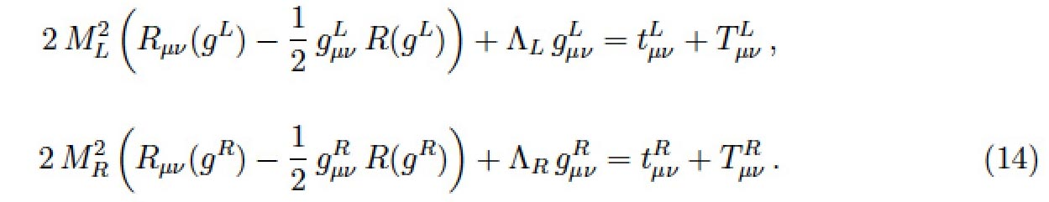

with the Lagrangian

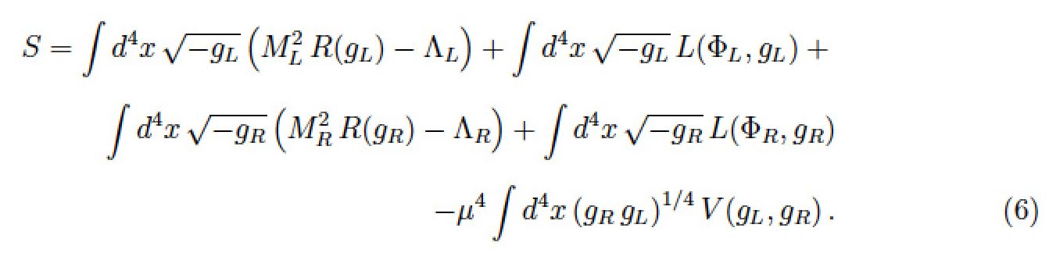

With "Janus" notations, by opting for a nullity of the two cosmological constants and by taking  this can be written :

(1) 

(2) 

In the second members the sources of the fields determining the geometries of the sectors "+" and "-" or "Right" and "Left" according to your notations.

Your terms  and  reflect the interaction between these two sectors

-  represents the contribution to the field, which determines the geometry "+" ("right") due to the presence of masses "-" ("left").

-  represents the contribution to the field, which determines the "-" ("left") geometry due to the presence of "+" ("right") masses.

The "Janus" writing convention is translated as :

(3) 

(4) 

The form of the first two members then requires that the differences of the second two members be null and void.

In order to demonstrate the inconsistency of the Janus system you choose to opt for the :

- Stationary situation

- Presence of a positive mass, of constant density, located inside a sphere (that is to say, schematically, a "star").

- Zero negative material density ("left").

The system then becomes, with your notations :

(5) 

(6) 

It should be noted at this stage that there is no definition of how the tensor should be constructed. It is the effect of "induced geometry" created in the "left" sector by the "right" material. All that could be said is that this tensor should be a function of the "right" content, i.e.

(7) 

The proposal of the "Janus" model amounted to giving this term the form :

(8) 

To show that the inconsistency appears even in an almost Lorentian situation, in your article, page 2, equation (5) you introduce a tensor  according to :

(9) 

The conditions of zero divergence of the two equations are then written (your equations (7) and (8), page 3 of your article) :

(10) 

(11) 

Where the operators and are constructed from the two different metrics and .

What is the physical meaning of these zero divergence conditions? These are conservation equations. It is therefore not surprising that equations (10) and (11) lead to Euler-type equations, which express the fact that, in the star, the force of gravity balances the force of pressure.

The calculation leads to :

(12) 

(13) 

Equations which, as you rightly point out, contradict each other.

Let's now go back to physics by deciding to write the Janus equations in their mixed form:

(14) 

(15) 

Like you, I took Einstein's constant equal to unity.

The tensors then write:

(16)



In this case the Janus system is reduced to :

(17) 

(18) 

The contradiction is then expressed when calculating the differential equation giving the pressure as a function of the radial variable. This corresponds to Tolmann Oppenheimer Volkoff's equation. For equation (17) we obtain :

(19) 

With  where M is the mass of the star.

When we pass to the Newtonian approximation this equation becomes

(20) 

We're back to Euler's equation.

The same thing, applied to equation (18) provides :

(21) 

The Newtonian approximation then provides:

(22) 

*It's an equivalent way of bringing out this contradiction that you raise.*

But it is also a way of discovering its origin, which comes from the choice made to express the tensor  responsible for the induced geometry effect.

However, there is no a priori physical reason for this tensor to be written:

(23) 

**We are going to consider modifying the system of Janus coupled field equations as follows and this is what I did in the article I published in march 2019 in the peer-reviewed journal Progress in Physics and which you did not consider (I asked you to put a link in your page of the IHES site) :**

Remaining in the expression of the equations in their mixed form, let us consider modifying the tensors responsible for the effects of induced geometry, which amounts to suggest moving from the system (14) + (15) to the system :

(24) 

(25) 

**Let's remember:** no physical imperative imposes a particular choice of the form of these tensors and . On the other hand, the form of the first members imposes the mathematical imperatives of zero divergence that we have pointed out, and which we cannot escape.

**Let's show that the choice:**

(26) 

(27) 

allows us to satisfy this mathematical imperative conditions. Let us take again the configuration you have considered in your article, i.e. the situation of a star of positive mass, surrounded by vacuum :

(28) 

(29) 

everything is in order (details of the calculations are provided in the appendix). The second differential equation becomes :

(30) 

which, in Newtonian, restores the Euler equation, reflecting the balance between pressure and gravity in the star. :

*The physical and mathematical inconsistency disappears.*

Both equations satisfy (asymptotically, in Newtonian approximation) Bianchi's identities.

**At this point, someone might say:**

- That's very clever. To make this difficulty disappear Petit has tinkered with the tensors present in the second limbs so that the inconsistency linked to the emergence of Euler's equation, translating the balance between the forces of pressure and gravity into the masses, disappears .

But, as we have pointed out, the incoherence linked to the emergence of the Euler equation, which reflects the balance between the forces of pressure and gravity in the masses, will disappear.

what determined the shape of the tensors  and  responsible for the induced geometry effects? Here, using your formulation:

(31) 

(32) 

*Nothing a priori!*

In the Newtonian approximation (linearization) the effect of pressure is neglected in relation to the density term . By saying that this system will only be valid for linearized solutions, it provides about ten results in agreement with the observations.

In this linearization viewpoint we will have tensors in the form :

(33) 

The three diagonal terms being finally neglected.

How then to complete these tensors by adding these missing diagonal terms?

Answer (from physicist): by making sure that the Euler equations (equilibrium, in regions where masses are present, between the force of gravity and the force of pressure) are satisfied. This is equivalent to wishing that the equations satisfy (asymptotically) the Bianchi conditions.

This leads to the choice (26) + (27).

This is the answer I gave you in this article published in Progress in Physics, which you probably haven't read.

I saw that Nathalie Deruelle had been your adviser in the making of your article. I proposed to you and to her a meeting in a room with a blackboard, without witnesses or recording, which would allow me to expose this work and answer your questions. Neither of you had the simple courtesy of simply answering me.

The text, which still appears on your IHES page, discredits me as a scientist, not only with French people, but within the entire international scientific community. You can of course choose not to subscribe to my requests. In this case, what I can tell you is that, failing to obtain a legitimate debate with the people who are supposed to be specialists in these matters, this whole affair will ultimately be brought to the attention of the greatest number, in French and in English, via one or more videos, with all the details of the calculations provided in attached pdf files.

A new situation is emerging. Through the series of about thirty Janus videos, using my talents as a teacher, I have exposed all the ins and outs of the approach we have undertaken for so many years, underlining in passing the contradictions in which contemporary cosmology and astrophysics are sinking deeper and deeper, by resorting to the undefined concepts of dark matter and dark energy.

You are the only one to have reacted in a constructed and argued way through the article that you have positioned in your page of the IHES and we are grateful to you for that.

Everyone knows that models don't come into being all at once, in their most elaborate form. Your comment therefore prompted a necessary reworking of the model, with publication in a peer-reviewed journal (which was in progress at the time). This is a purely mathematical reworking, which, by the way, does not in any way change the results already obtained and published and the many points of agreement with the observations. From this point of view, we can only be grateful to you for having highlighted this shortcoming and for having prompted this progress.

- I therefore request that you add the contents of this letter to this page of the IHES, as an exercise of my scientific right of reply. Even if you put forward any arguments that contradict my arguments.

Unless you would prefer to put this link on your page of the IHES site /

- I ask you to put the link to my progress in physics article:

- I ask you to put a link to the translation of your own article in English, through the link:

Or to reproduce this text in your page of the IHES website.

- Insofar as we have responded to your legitimate objection, it would be appropriate for us to be able to present this work, "revisited", in a seminar at the IHES, and I am rephrasing this request to you.

Sincerely yours Jean-Pierre Petit

**References** :

[1] T.Damour : Sur le modèle « Janus » de J.P.Petit <http://www.ihes.fr/~damour/publications/JanusJanvier2019-1.pdf>

[2] J.P.Petit : Physical and mathematical consistency of the Janus Cosmological Model. Progress in Physics 291 Vol.15 issue 1. (<http://www.ptep-online.com> )

[3] S.Hossenfelder Antigravitation Physical Letters B vol. 636 issue 2 4 may 2006 pp.119-125

[4] J.P.Petit, G.D’Agostini : Negative Mass hypothesis in cosmology and the nature of dark energy. Astrophysics And Space Sccience,. *A* **29**, 145-182 (2014)

[5] G. DAgostini and J.P.Petit : Constraints on Janus Cosmological model from recent observations of supernovae type Ia, Astrophysics and Space Science, (2018), 363:139.[https://doi.org/10.1007/s10509-018-3365-3](https://doi.org/10.1007/s10509-018-3365-3" \t "_blank)

[6] J.P.PETIT, P.MIDY & F.LANDSHEAT : Twin matter against dark matter. Intern. Meet. on Atrophys. and Cosm. ["Where is the matter ? ",](http://www.jp-petit.org/science/colloque2001/Colloque2001_0.html) Marseille 2001 june 25-29

[7] J. P. Petit, Astrophys. Space Sci. Twin universe cosmology **226**, 273 (1995).

[8] W.B.Bonnor : Negative mass and general relativity. General Relativity and Gravitation Vol.21, N°11, 1989

[9] J.P.Petit & G.D’Agostini : Lagrangian derivation of the two coupled field equations in the Janus Cosmological Model. Astrophysics and Space Science 2015, 357 :67

[10] G. DAgostini and J.P.Petit : Constraints on Janus Cosmological model from recent observations of supernovae type Ia, Astrophysics and Space Science, (2018), 363:139.[https://doi.org/10.1007/s10509-018-3365-3](https://doi.org/10.1007/s10509-018-3365-3" \t "_blank)

[11] J.P.PETIT : Cosmological model with variable velocity of light. Modern Phys Letters A3, 1988, pp. 1527

[12] The Dipole Repeller : Y Hoffman, D.Pomarède, R.B.Tully, H.Courtois. Nature Astronomy 2017 1 , 0036

[13] T.Damour and II Kogan Effective Lagrangians and universality classes of non linear bigravity Phys Rev D 2002

APPENDIX 1

Putting elements of your own article into perspective

and the way we'd dealt with it.

Quotations from excerpts of your text are indented.

In red, the modification of your analysis, based on the new 2019 system of field equations [2] which corresponds to (28) - above.

You note [1] notes that due to the structure of the first members of the Janus field equations we have the relation :

 (2)

 (3)

Adding that these Bianchi identities imply conservation laws for the corresponding sources. Your text:

*Since the (Janus) equations consist of two Einstein-type equations, these equations imply two separate conservation laws for their two right-hand members .*

This is where the reasoning will be taken up again.

You start from the Janus system of 2015 [9].

 (1a)

 (1b)

with : 

and you're posing: 

You write:

*The two tensor sources  and  are supposed to represent, respectively, the impulse energy of ordinary matter (called "positive mass") and of a new matter called "negative mass".*

In the 2019 paper [2] the field equations have been modified and, along with your notations, they should read: :

 (1a’)

 (1b’)

In the second members the source terms of "induced geometry" (i.e. managing how the geometry of a population is influenced by the energy-matter distribution of the second) are replaced by and  .

You then move on to the case where negative mass is absent :

 (4a)

 (4b)

Which is to be replaced by the system

 (4a’)

 (4b’)

You then write

  

and :

 (5)

This must be replaced by the choice made in Janus 2019 [2] :

 (5’)

You remind us that we have to have:

 (7)

 (8)

True, but now modulo the modification (5')

Note: Please note your choice of signature: . I choose But it doesn't have any consequences.

Page 5 You write :

*"Let me first recall that the linearized solution of Einstein's equations in the usual Einstein equation (say the first system in (6)) can be written :*

** (19)

*where the quasi-Newtonian potential U satisfies the Poisson equation*

 (20)

*Because of the formal symmetry between the two system equations (6), a linearized solution of the Einstein-type equations for metrics is written as :*

** (21)

*where the quasi-Newtonian potential  satisfies the modified Poisson's equation*

 (22)

*According to equation (5) the source of this modified Poisson equation (denoted here ) is, at the lowest approximation which suffices here (since the ratio , simply the opposite of the usual source.*

 (23)

There I still agree, although in Janus 2019 [2], if this second tensor becomes .

I continue.

*As a result, the quasi-Newtonian potential entering the second metric is also the opposite of the usual potential:*

 (24)

It is at the beginning of page 6 that you write (based on the Janus 2015 equations [9]):

*The spatial part of the source tensor for Einstein's second equation is:*

 (25)

And there, if we base ourselves on the Janus equations of March 2019 [2] , which are :

 



with :

1.  

Ce que je suis parfaitement en droit de choisir, alors le signe de la partie spatiale du tenseur source de la géométrie induite *est inversé*.

Then you write on page 6 [1] :

*I recall the explicit formula of  (where I call that  )*

 (26)

*En appliquant cette formule au cas statique d’une étoile et pour un indice spatial un indice spatial  valant *

 (26)

*In the last term the contribution of dominance , in the quasi-Newtonian case ( because  while and . We then find :*

 (28)

It is this equation that reflects Euler's relationship of static equilibrium in a usual fluid, let’s recall 

 (32)

 (30)

With the Janus equations of 2015 we will have well, as he indicates at the top of his page 7 :

*In this second Euler equation we can replace  ,  and  by their values, i.e. in the lowest order by - ,  and  . This gives*

 (31)

A contradiction then appears between two contradictory Euler equations. But this contradiction disappears with the Janus 2019 equations [2] where the equivalent sentence will be :

*Dans cette seconde équation d’Euler on peut remplacer  ,  et  par leurs valeurs, c’est à dire à l’ordre le plus bas par  ,  et  . Cela donne :*

*In this second Euler equation we can replace  ,  and  by their values, i.e. in the lowest order by  ,  , and  . This gives :*

 (31)

*and the contradiction disappears.*

And there we see the sufficient reason presiding over the choice of the source terms of the "induced geometry" which serves as a guide for the Janus 2019 equations [2] :

***In order to cancel any contradiction in the Euler equations***

**In addition** :

What has just been established for a region of the universe where negative mass would be practically absent, in a negligible quantity, can be extended to the opposite: to a portion of space where, in a situation considered stationary, it is on the contrary negative mass that dominates and where positive mass can be neglected. This will correspond to the system of coupled field equations :

(32)  

(33)  

Bianchi's relation referring to the second equation will provide the equivalent of a Euler equation for this negative matter, reflecting the balance between the force of gravity and the force of pressure.

But this same constraint, referring to the first equation of the system will have no physical meaning and will only express the necessary mathematical compatibility between the two solutions , which will be ensured if the induced geometry effect (in the sector of positive masses, due to the present negative masses corresponds to the expression of the tensor of the second member in the form :

(34) 

Bianchi's relation (common to both equations) will correspond, with your notations, to

(35) 

where the gravitational potential  is then created by negative masses.

By pushing the construction of metric solutions, we will obtain in particular, for the one describing the behaviour of positive energy particles :

Inner metric :

(36)



with :



Exterior Metric  :

(37)



with 

In linear form:

(38) 

Which corresponds to a phenomenon of repulsion. This explains the phenomenon of the Great Repeller, discovered in January 2017 [12] . It has been shown that in a direction roughly opposite to that of the Shapley attractor there existed an apparently empty region that seemed to repel all matter.

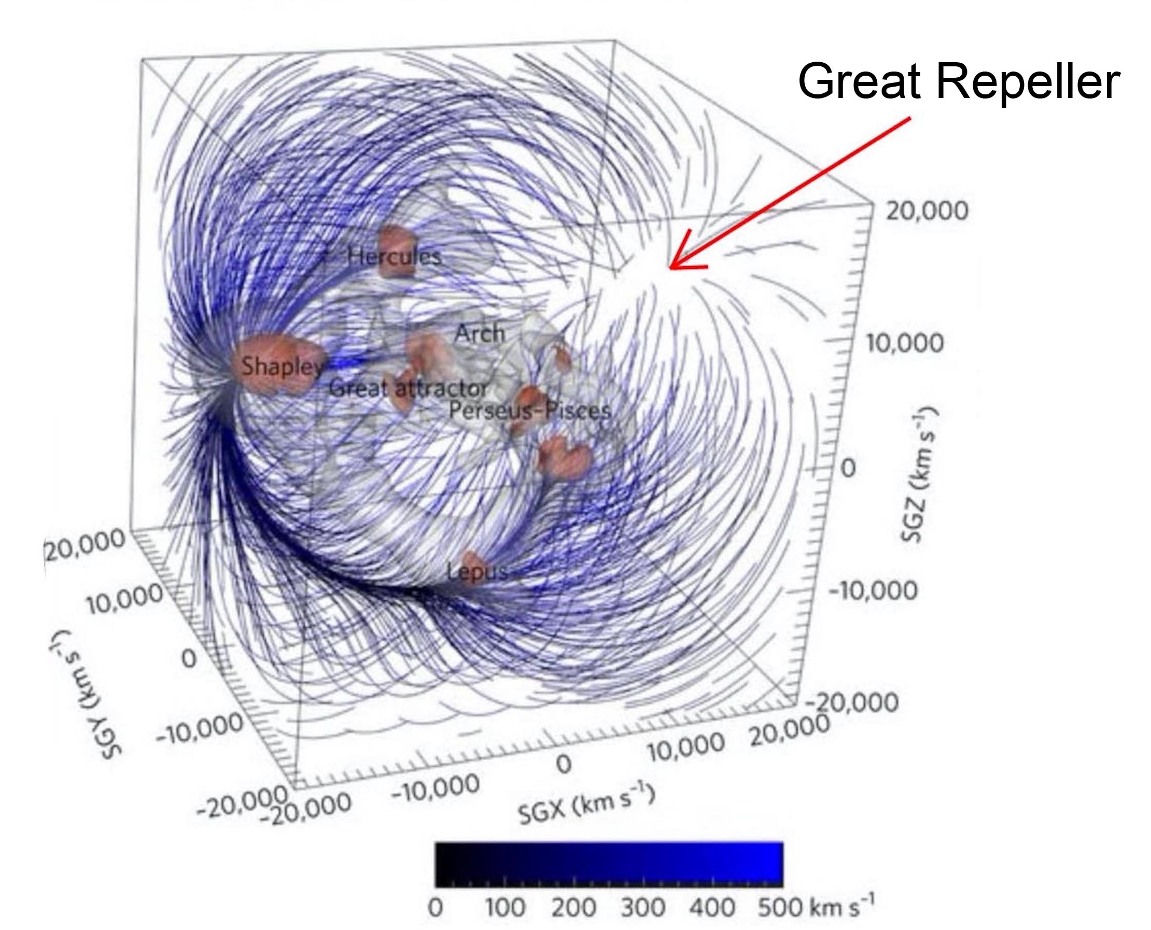

Figure : Thee Great Repeller

As suggested as early as 1995 years these negative mass conglomerates create a negative gravitational lens effect which has the effect of reducing the brightness of distant, background sources. Effect which, according to us, explains the low magnitude of galaxies at z > 7.

This being the case, a fine analysis of the magnitudes of the distant sources located in the direction of the Great Repeller should provide access to the diameter of this negative mass conglomerate, which is invisible since it emits negative energy photons.

**To sum up :**

* So we have a system of two Janus coupled field equations, whose scope is limited to linearized, quasi-Newtonian solutions.

1. - Which derives from an action
2. - That satisfies Bianchi's identities
3. - Which takes care of all the classic situations of the RG
4. - It's an advantageous substitute for dark matter and dark energy.
5. - Fits a dozen or so observational data.

In spite of the progress represented by the first evidence of the existence of gravitational waves, cosmology suffers from not being able to highlight the hypothetical dark matter nor being able to provide any model for this other component represented by this no less hypothetical dark energy.

The Janus model is the only one to provide a well-founded description of the nature of these invisible components of the cosmos, namely antimatter (antihydrogen of negative mass). The model explains in passing the non-observation of primordial antimatter, giving substance to André Sakharov's initial 1967 idea. It is consistent with a good dozen observational data sets.

It is shocking that all the doors of French seminars in the field have been closed to us for the last five years. In your registered letter of 7 January 2019, you confirmed your refusal to see me present this work to the IHES. I am rephrasing this request once again in the hope that my letter will have made you change your mind.

I also ask you to reproduce these clarifications on the Janus model in both languages, French and English, accompanying the English translation of your own article, which I have attached. My foreign colleagues are waiting to read the criticisms/responses in order to be able to form their own opinion on this model.

If there is no real debate on these issues a situation will continue to develop where finally non-specialists end up having a clearer global vision than specialists, the attitude of a man like Lachièze-Rey being an example of this irrational and absurd deafness.

https://www.youtube.com/watch?v=Vl541wUXsSs&feature=youtu.be

We hope that this mailing will help to clean up this situation, which is in urgent need.

Jean-Pierre Petit

**References** :

[1] T.Damour : Sur le modèle « Janus » de J.P.Petit <http://www.ihes.fr/~damour/publications/JanusJanvier2019-1.pdf>

[2] J.P.Petit : Physical and mathematical consistency of the Janus Cosmological Model. Progress in Physics 291 Vol.15 issue 1. (<http://www.ptep-online.com> )

[3] S.Hossenfelder Antigravitation Physical Letters B vol. 636 issue 2 4 may 2006 pp.119-125

[4] J.P.Petit, G.D’Agostini : Negative Mass hypothesis in cosmology and the nature of dark energy. Astrophysics And Space Sccience,. *A* **29**, 145-182 (2014)

[5] G. DAgostini and J.P.Petit : Constraints on Janus Cosmological model from recent observations of supernovae type Ia, Astrophysics and Space Science, (2018), 363:139.[https://doi.org/10.1007/s10509-018-3365-3](https://doi.org/10.1007/s10509-018-3365-3" \t "_blank)

[6] J.P.PETIT, P.MIDY & F.LANDSHEAT : Twin matter against dark matter. Intern. Meet. on Atrophys. and Cosm. ["Where is the matter ? ",](http://www.jp-petit.org/science/colloque2001/Colloque2001_0.html) Marseille 2001 june 25-29

[7] J. P. Petit, Astrophys. Space Sci. Twin universe cosmology **226**, 273 (1995).

[8] W.B.Bonnor : Negative mass and general relativity. General Relativity and Gravitation Vol.21, N°11, 1989

[9] J.P.Petit & G.D’Agostini : Lagrangian derivation of the two coupled field equations in the Janus Cosmological Model. Astrophysics and Space Science 2015, 357 :67

[10] G. DAgostini and J.P.Petit : Constraints on Janus Cosmological model from recent observations of supernovae type Ia, Astrophysics and Space Science, (2018), 363:139.[https://doi.org/10.1007/s10509-018-3365-3](https://doi.org/10.1007/s10509-018-3365-3" \t "_blank)

[11] J.P.PETIT : Cosmological model with variable velocity of light. Modern Phys Letters A3, 1988, pp. 1527

[12] The Dipole Repeller : Y Hoffman, D.Pomarède, R.B.Tully, H.Courtois. Nature Astronomy 2017 1 , 0036

Appendix 2

This contains all the calculations (oh so tedious, as is always the case in differential geometry) that support the reasoning presented in the body of the article.

As a general rule we are in the case of a spherically symmetrical geometry.

In this case the two metrics are written as follows:

(1) 

(2)

In the following, to lighten the writing, we will ask:















We will perform the calculations starting from an expression of the field equations presented in mixed form :

(3) 

(4) 

We will then opt for the configuration envisaged by Damour, considering a part of the space where negative mass is absent, i.e. the equations :

(5) 

(6) 

- The first equation can then be identified with Einstein's equation without cosmological constants.

- The second equation translates an "induced geometry effect" (on geodesics of the negative mass species, due to the presence of positive mass inside a sphere of radius, density 

We will try to stick with the notations used by T. Damour [1] in his paper. He writes our system (5) + (6) according to his equation (4), page 1 :





then he asks (his equation (4) )



This leads him to write the system of equations (his equations (6)):



And then we get to the source of his critique of the two-equation system. Indeed, the structure of the first members imposes that :

(7) 

(8) 

Therefore we must have the conservation laws (his equations (7) and (8) on page 3 of his paper):

(9) 

(10) 

We will resume the thread of its calculation at the end of this Appendix 1. Still, by giving the tensor the form corresponding to the unmodified Janus equations, equations (9) and (10) led to contradictory Euler equations (equations (32) and (33) on page 7 of his paper).

How to get out of this impasse?

By noticing that we are totally free in the choice of tensors reflecting the effects induced (by a material on the material of opposite sign). As we will show by taking again all its calculation by the menu, a light modification of the tensor  brings the solution, without modifying by one iota all the aspects related to the solutions emerging from the two coupled equations ("interior" metrics, that is to say inside the star and "exterior" metrics, outside the star).

When we start to calculate the exact solution of this system, if we do not take this precaution, we would also see this kind of contradiction, inside the star, in the form of the emergence of two equations of the Tolmann Oppenheimer Volkoff type, which are also contradictory. In what will follow, which translates the construction of the two metrics as a whole, modulo this precaution, this problem will not appear. But to convince the reader, we will take up this whole scheme according to the approach followed by Damour [1] .

Below is the calculation of the components of the Ricci tensor and the first limb, for the positive species.

We have :

(11)

  

With metrics in this form the non-zero components of the Ricci tensor are :

(12)

 

 

 

 

Ricci scalar :

(13)



Which gives the Einstein’s tennsor:

(14) 

(15) 

(16) 

Let's write the equations corresponding to the first of the two field equations, in Damour's notations [1] , in a mixed writing

(17) 

(18) 

(19) 

(20) 

Et aussi :

(21) 

We will now consider the outer metric, where the second members of the equations are zero. The method is described in reference [2] , in chapter 14, and it corresponds to :



(22) 

Avec

(23) 

M being the (positive) mass of the star.

Let's move on to the classical construction of the inner metric [2] . We have:

(23)



The equations are written:

(24) 

(25) 

(26) 

(27) 

Whence:

(28) 

(29) 

To solve, we write :

(30)  soit 

Whence:

(31) 

(32) 

(33) 

i.e. :

(34) 

(35) 

(36) 

We will eliminate by deriving equation (25)

(37) 







Combining to requation (29) we get :

(38) 

(39) 

Using (27) we get :

(40) 

with

(41) 

At the end we get the « TOV »[[1]](#footnote-1) equation ( Tolmann-Oppenheimer-Volkoff ) :

(42) 

When we apply Newtonian approxximatio  we get

(43)



In spherical symmetry, the gravitational field which prevails at a distance  (inside the star of supposed constant density) is equal to the field which would be created by the mass contained in a sphere of radius rs, concentrated in the centre. Thus equation (43) can be identified with the conservation equation (32) on page 7 of Damour's paper :



Although it is terribly tedious it is essential to resume, line after line, all these calculations (here, classical) in order to extend them to the calculation of the inner metric describing the negative species. When this will be done, further on, we will see that without this precaution taken concerning the tensor we would end up with the same contraction.

Continuing the calculation, we will now explain the complete calculation of the interior metric .

Taking the notation of the reference [2] we ask :

(44) 

As has been established above (34) that :

(45) 

This will immediately give us one of the terms of the metric:

(46) 

And so our inner metric is written:

(47) 

The function  has yet to be determined. The density is assumed to be constant . We have..:

(48)  🡺 

(49)  🡺 

We use (25) to solve

(50)  🡺 

(51) 

Writong  🡺 

(52) 

A particular solution of the equation is 

We must find a general solution to the homogeneous equation:

(53)  🡺 

whence :

(54) 

(55) 

where :

(56) 

Let us now express that the pressure on the surface of the sphere is zero:

(57) 

(58) 

QWhen  we get p = 0

(59)  🡺 

Il reste à déterminer B, ce que nous allons faire en imposant que les métriques intérieures et extérieures se raccordent sur la surface de la sphère. Ce qui se traduit par :

(60) 

(61) 

(62) 

(63) 

(64) 

(65) 

Following, the inner metric[[2]](#footnote-2) :

(66) 

We are now going to deploy the same calculation scheme, but this time adapting it to the metric describing the negative mass species, which is then the solution of the equation : (67) 

The determinants ratio can be written:

(68) 

kD is close to untity because we deal with Newtonian approximation.

This time we calculate the impact of the presence of the positive masses on the geometry of the negative sector. We recall that we are perfectly free to choose this tensor , as this choice can result from a Lagrangian derivation. And we have seen, choice XVIII, that we opt for :

(69)



hypothesis which does not weight on the whole model since in the Newtonian approximation the pressure terms are always negligible. This therefore limits the scope of the model to this field of the Newtonian approximation. But this one covers all known observations.

We will show that this option no longer leads to the inconsistency reported by Damour in his paper.

Once again, we decline the construction of the first member from a metric which this time is :

(70) 

The first members of the equations are the same, simply replace  with . We then get

(71) 

(72) 

(73) 

(74) 

(75) 

To soove we write

(76)  soit 

(77)  🡺 

Using (71) :  🡺 

In conclusion, at this stage:

(78) 

We get

(79) 

To eliminate  we dérive (72)

(80) 







Combining to (75) we get

(81) 

(82) 

Using (74)

(83) : 

Finally:

(84) : 

To be ompared with what emerged from the analysis for positive masses, i.e. equation (43):



These differential equations are not identical, unless the Newtonian approximation is used, then they lead to the same result

(85) : 

Which is equivalent to (32) :  from Damour’ paper [1] , page 7.

The physical and mathematical inconsistency of the model disappears. One could object that this limits the solutions to those that fit this Newtonian approximation. But in cosmology, what more do you ask for?

Better a model that provides calculation results limited to the conditions of the Newtonian approximation (i.e. to all the data available observationally) than an extremely ambitious model (Damour and Kogan 2001) that promises us non-linear solutions but which, in the end, does not offer a possible confrontation with the observations.

We are going to finalize the calculation of the inner metric of the negative species, as we did earlier. We will not omit any intermediary of calculation to be sure that an error (it happened quickly) will not slip into the process.

(86) 

To express inner metric:

(87) 

Given that by assumption is constant.

(88) 

(89) 

Write:

(90) 

To soove we use (74)

(91) 

(92) 

(93) 

Let :

(94)  🡺 

whence:

(95) 

A particular solution to this differential equation is :

(96) 

We have to find the general solution to the homogeneous equation:

(97) 

that is:

(98) 

Whence the general solution is :

(99) 

Let’s calculate the components eof the metric  :

(100) 

We get:

(101) 

We know that :

(102) 

(103) 

The pressure on the surface of the sphere is expressed as zero.

(104) 

To determine B we will make sure that there is a continuous connection between the inner metric and the outer metric, where r = rs

We know we have:

(105) 

(106) 

(107) 

(108) 

(109) 

(110) 

Let’s write the final expression of the inner metriv 

(111)



which fits the exterior metric

(112) 

Linearized forms :

(113) 

(114) 

**References** :

[1] T.Damour : Sur le modèle « Janus » de J.P.Petit <http://www.ihes.fr/~damour/publications/JanusJanvier2019-1.pdf>

[2] Adler, Schiffer et Bazin : Introduction to General Relativity.  
<http://www.jp-petit.org/books/asb.pdf>

Annexe 3 :

Thibaud Damour, IHES 2019 January the fourth

**About the « Janus Cosmological Model of J.P.Petit**

( translated by J.P.Petit )

Before all let us give our conclusion :

*The « Janus Cosmological Model » is physically (and mathematically ) unconsistent*

The Janus equations are the following :

(1a) 

(1b) 

With 

The classical definition of which ensures its tensorial conservation with respect to is :



Where  refers to the action of the ordinary matter. There is no need to give the definition of , which was not precised in the works of Petit and d’Agostini.

The « Janus Model » does not fit the Bianchi identities. In effect the system (1a) + (1b) goes with :

(2a) 

(2b) 

Consider the case  so that the Janus system becomes :

(3a) 

(3b) 

Let us write :









The the Janus system becomes :

(4a) 

(4b) 

with (4c) :

****

The authors have introduced the factor  is order to cure a difficulty to some unconsistency linked to a simplified model but as will be shown further this does not prevent the severe unconsistency in the case of the hydrostatic equilibrium when we consider the cas of a self-gravitating star, in the Newtonian limit 

The central point is based on the constainsts

(5a) 

(5b) 

where  is the connection linked to .

To illustrate such point let us consider the simple case where the « positive » matter comes both from a background source  ( for example a star, or the sun in our solar system ), considered as a sphere filled by a uniform distribution of « dust », i.e , then :

(6a) 

(6b) 

where

(7) 

(8) 

(9) 

Here the covariant 4-velocity field  is, defined with respect to the metric  , so that  . Considered with respect to the second metric  the co-vectorial field defines in a unique way the equivalent 4-velocity field  (with ) as defined above.

Now consider the two conservation laws (5a) and (5b).

Let us first concentrate on the movement of the test dust matter. The laws (5a) and (5b) the following constrainst :

(10) 

(11) 

(12) 

(12) 

The physical meaning of the equation (10) is the following. It shows that the lines of the universe of the matter (defined by  ) are geodesics of  , while the third equation (12) says that the same positive matter is also ruled (by the equations  ) to obey another equations of the movement  which shows that the line of the universe defined by  must be geodesics derived from the metric. But the 4-velocity field  is not independent of . Considered as a covariant field it is basically the same through a renormalization factor , equation, so that  As the two metrics  and  are a priori different I don’t see how it could be possible ( considering a complex general time dependent solution, defined by arbitrary Cauchy data for  ) to have the same matter following different motion equations. If we consider for example some initial velocity data for a a test dust, such velocity would be supposed to folllow at the same time two distinct rules of evolution, which is mathematically absurd for a classical theory !

Another physico-mathematical contradiction may arise from equations (4a) and (4b) applying such system to the structure of a self-gravitating star, in Newtonian limit. Consider a background source corresponding to a perfect fluid :

(13) 

I will limit the analysis to the almost Newtonian conditions. I will show that this theory is self contradictory and does not lead to any physical solution.

I recall that the linearized solution of the Einstein equations may be written :

(14) 

where U is the newtonian potential from Poisson equation :

(15) 

Due to the formal symmetry of the system (4a) + (4b) we get the corresponding linearized solution :

(16) 

where the quasi Newtonian potential  obeys :

(17) 

from (9) with   is simply -  . So that :

(18) 

Now I shift to another thing that shows the unconsistency of the « Janus Model ». After equation (4c)

(19) 

It is now very important to take in charge the consequences of the equations (5a) and (5b) which act on the same energy-impulsion tensor.

I recall :

(20) 

If i refers to space :

(21) 

In the Newtonian approximation, in the last term the contribution from  is dominant because  while  and . Then

(22) 

I recall that in the Newtonian approximation the order of magnitude of  is unity, i.e. is when  .

For example, for a perfect moving fluid we have  Then the above equation (when fullfilled by  ) is nothing ( when ) but the classical hydrodynamical Euler equation. I have considered a static case, with the equilibrium of a self-gravitating star.

Now, consider the second conservation law (5b). We shall have :

(23) 

Thus, finally :

(24) 

In this second Euler equation :  then

(25) 

which contradicts the classical Euler equation (22).

If the star is filled by a perfect fluid this static equilibrium implies both

(26) 

CONCLUSION : The system of coupled equations of the « Janus Model » are mathematically and physically contradictory.

1. Which corresponds to equation (14.22) in reference [2]. [↑](#footnote-ref-1)
2. Equation (14.47) de la référence [2] [↑](#footnote-ref-2)